Hill Stations:

Bhurban

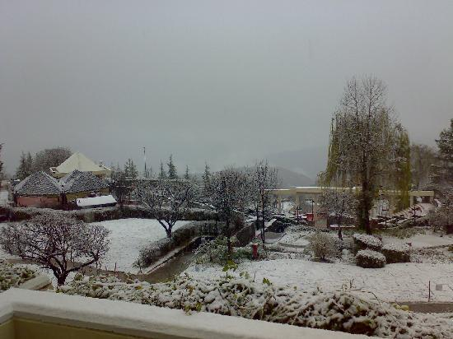

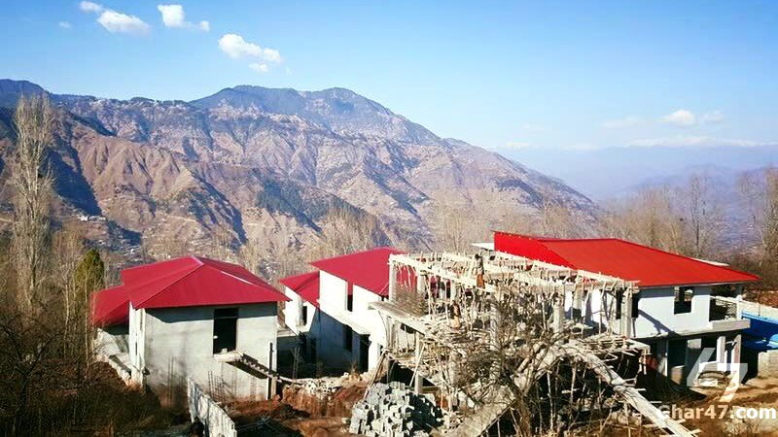

**Bhurban** is a small town and a hill station in Punjab province, Pakistan. The resort town is named after a nearby forest. It is located approximately 9 kilometres from Murree city. Bhurban is one of the more picturesque places in the country, and is a tourist paradise with unique flora, and a fauna with a variety species not found elsewhere in Pakistan. It is known for scenic hiking trails in the nearby Ayubia National Park. The '5 star' Pearl Continental Hotel - Mount Pleasant Apartments is one of several resorts in Bhurban that serve tourists visiting the Murree Hills and the national park. Bhurban also has a nine-hole golf course. Another beautiful resort in Bhurban is the Bhurban Hill Apartments, located 2km from PC Bhurban. It has its own source of natural mineral water.